Student Name: Xianglong Lin Student Number: 45791439 Team Name: H2OMG
Week: _2_
Title: Team Formation and Project Focus
Description:
In the 2nd week, I proactively collaborated with some friends from the previous week's wallet design to form a project team under the guidance of our tutors. We successfully formed a team with 2 additional members, each bringing unique educational backgrounds, skills, and experiences. After getting to know each other, we brainstormed around 3 themes: Home & Domestic Setting, Office & Workplace Settings, and Health & Wellbeing to decide our future direction. I preferred Theme 2, Office & Workplace Settings, due to my background as an IT project manager at Huahong International Law Firm. However, we ultimately agreed on Theme 1, Home & Domestic Setting, as it resonated more with each team member's personal experiences and insights. We then narrowed Theme 1 down to a more specific focus: communication among household members or water usage. Upon further brainstorming and research, we discovered that a project centred on water usage was more feasible compared to communication. Water is a universal need, and everyone requires it similarly, whereas communication methods vary greatly from household to household and depend on individual circumstances. After selecting our main theme and specific focus, we created two personas, Trump and Jeff, and developed corresponding scenarios. We also established a WhatsApp group to facilitate ongoing communication after the studio session.
Visual Evidence:
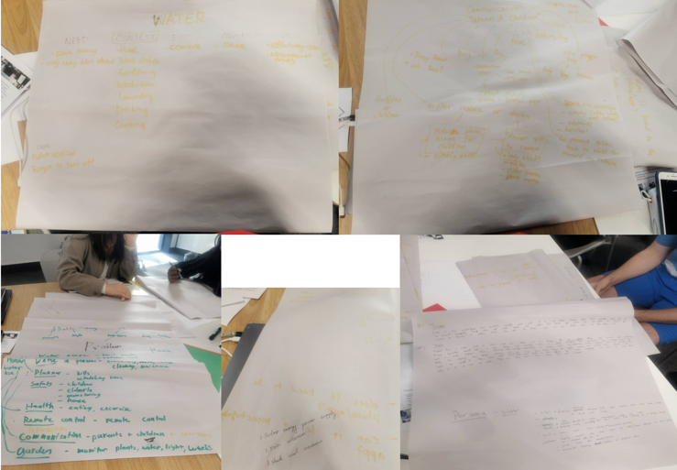
Statement on Learning:
The most important aspect of this studio was the core design principles emphasised by the tutor: 1. Who is the user? 2. What does the design do? 3. How does the design achieve this? Additionally, the common concern of whether the final solution should be an app, or a website was addressed, highlighting that at this initial stage, we should not focus on technology or worry about the final form of the solution. Adhering to these core principles, the team formation allowed us to break down the theme, making it more manageable for the project. We structured and divided the tasks, assigning each person roles based on their skills and strengths. The creation of Personas focused on the users' water usage needs, prioritising water recycling and minimising waste. This not only helped us clearly define the project goals and direction but also ensured the practicality and relevance of our design solution. Throughout this process, I learned how detailed user persona analysis can guide design decisions and enhance team collaboration, ultimately leading to more effective problem-solving.

